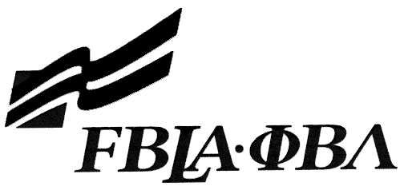
Future Business Leaders of America - Arizona

Skill Event Administration (School Site Testing)

Event Participant Certification Form (student form)

This Event Participant Certification Form applies to the following event: (check one)

_____ Computer Applications _____ Word Processing

As a Participant in the above indicated event, I certify that the following statements are true.

- I did not take more time than allowed by the test guidelines, and I completed the exam in one session.

2. No help, beyond that allowed in the instructions (i.e. equipment problems), was given to me.

3. I used no textbook, reference materials, or other aids other than the FBLA-PBL Format Guide.

4. All test materials generated are my original work, unless otherwise allowed in the Event Guidelines.

5. No test materials were copied in any way; no test materials remain in my possession or in the possession of anyone else not associated with FBLA-PBL Center.

6. Test materials saved to any hard drive or network drives are deleted.

7. All copies of the printed test materials, all test printouts (including drafts and discarded copies) are enclosed in the return packet.

8. Upon completion of the test, I placed all materials into the testing envelope and gave the envelope to the Event Proctor.

9. I am registered to attend the Regional Conference and to participate in the above indicated event. I plan to take the objective test associated with my event during and am aware that my score on that test will count for 15% of my final event score or as indicated by my event description.

Certified by: _______________________________ Date: _____________________

Name (Print): _____________________________ School: _____________________

